COS30018 - Option B - Task 5: Machine Learning 2

-Vivek Saini

In this assignment I will be talking about the models I have created for the purpose of machine learning. Starting off with the first requirement:

Implement a function that solve the multistep prediction problem to allow the prediction to be

made for a sequence of closing prices of k days into the future

First of all I have made a few tweaks before starting this assignment. I have commented out the box plot and other graphs because it was unnecessary. I have commented out the previous model and removed the input function that takes hyperparameters into context because it also had no use and was time consuming. Instead I have hard coded certain values.

First lets talk about the multistep Prediction model: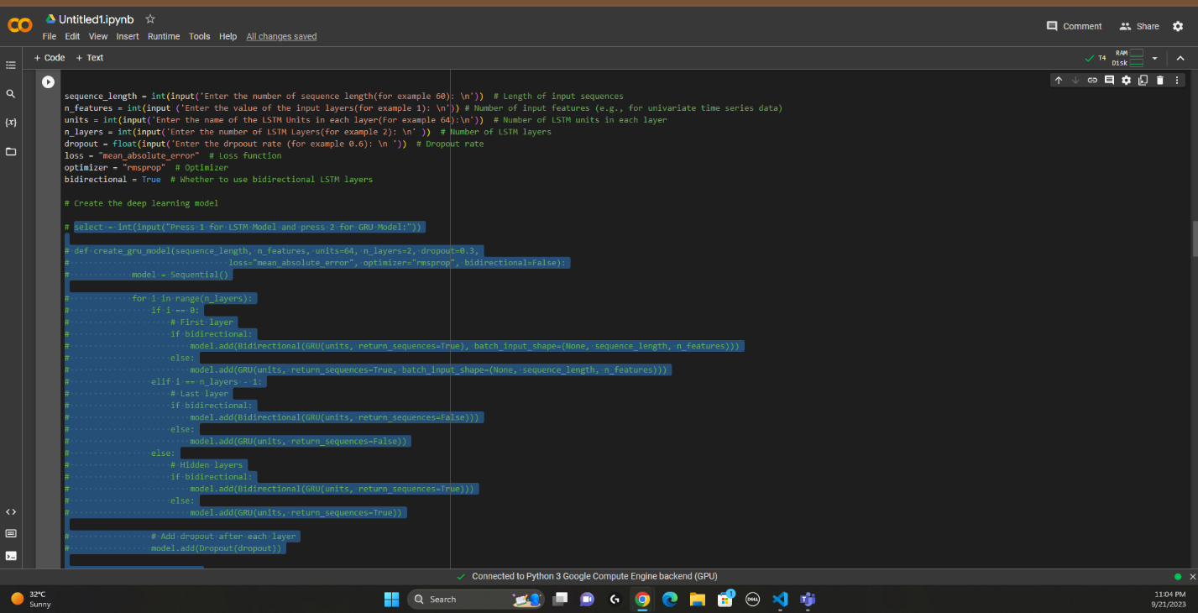

Also I have switched to google colab to perform this assignment.

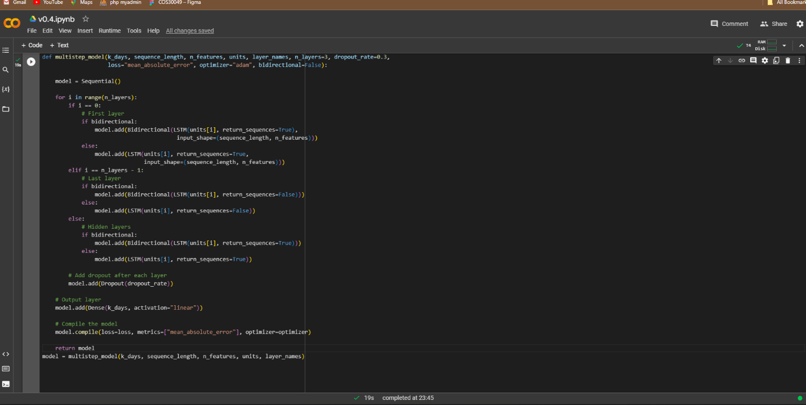

In the multistep model we define certain variables like k_days, which tells us how many days we will be predicting into the future and we can set this value later in this function. Then I have set the rest of the variables which were similar to the previous LSTM model. It was pretty straightforward till this step.

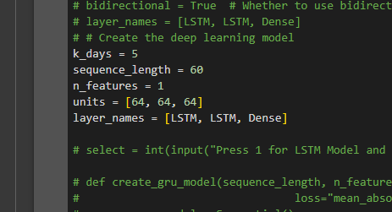

Then I have given some values to the parameters and then passed it into the function. 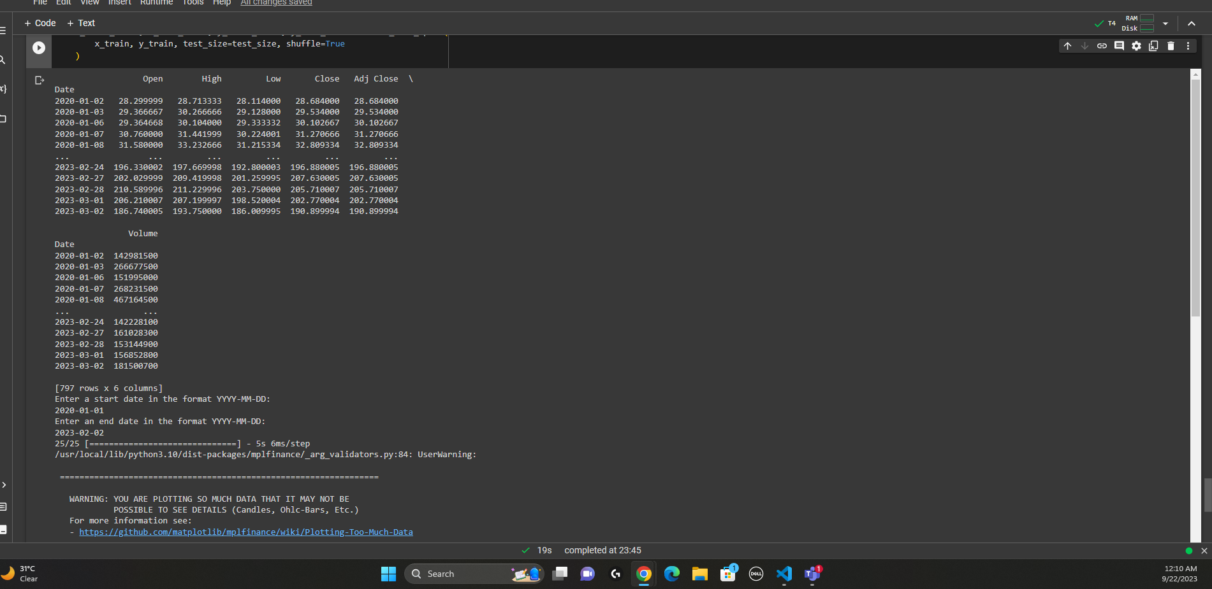

In this model we can see that it uses the data that I have defined in the very beginning of the code and loads it here according to the date range that we input.

As you can see the results of this function in the picture above, here is the charts of this function: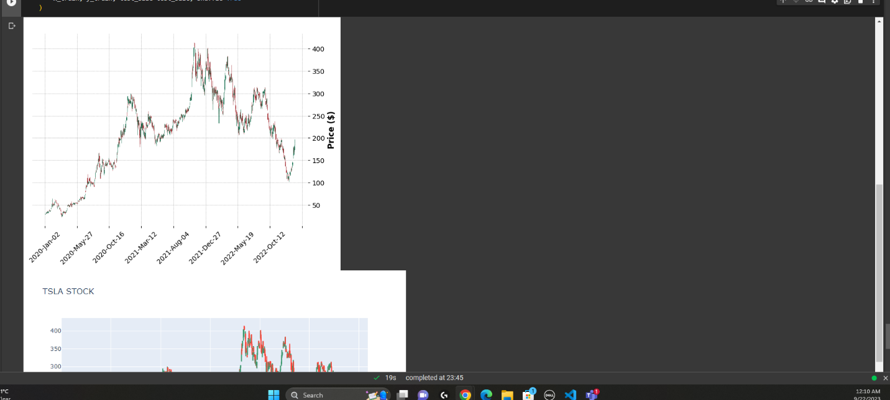

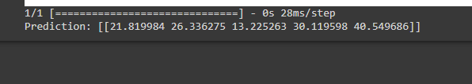

Moving on to the next step,

Implement a function that solve the simple multivariate prediction problem to that takes into

account the other features for the same company (including opening price, highest price,

lowest price, closing price, adjusted closing price, trading volume) as the input for predicting

the closing price of the company for a specified day in the future.

Here things get more complicated, this function took too long to make but in the end I figured out a way. Firstly, I was trying to make some changes in the existing model by changing the parameters and Creating an array including all the Features. And then passing into the function but it did not work because I was doing something wrong with the reshaping of this function.

After many tries I commented the whole thing out and started from beginning to make this function work.

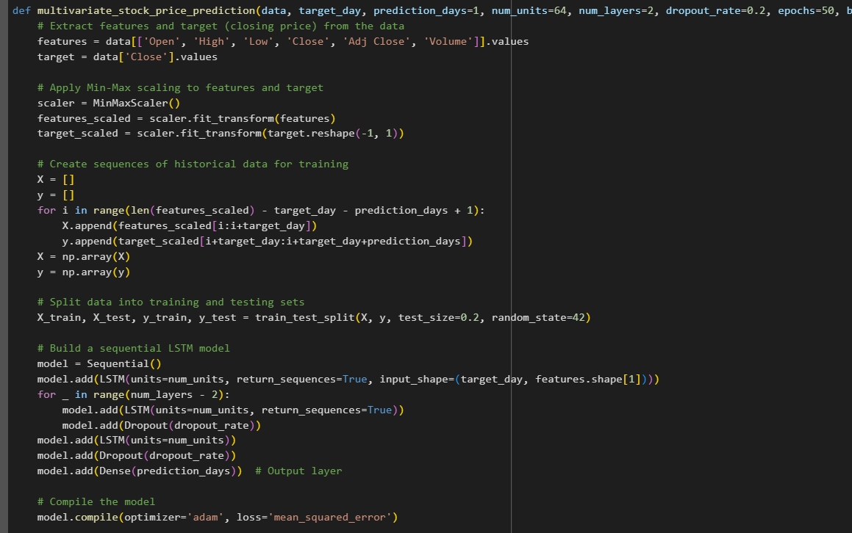

In this function I have created the variables, defined them, made the features array and passed on to take all those as inputs and then building the model to output in close. I have also made new data for training and testing of the data. I faced some issues here, my function wont work because I was repeatedly getting this error where it says the expected input of the numpy array is not correct as it should be. Spent some time here an there searching for it and ended up just making a new sequence that collects previous data and reshaped it accordingly. Hence I get these results.

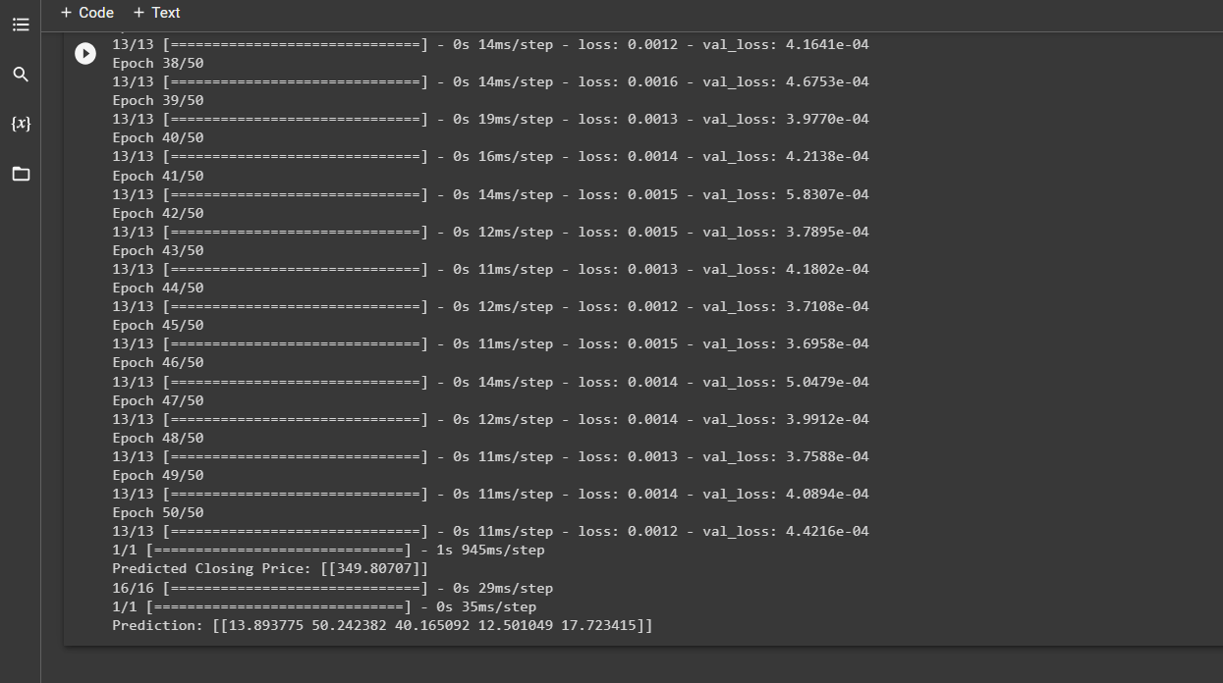

Changed the epochs and batch size to just check it was working by changing these parameters.

And at last we move on to the last step.

Combine the above two functions to solve the multivariate, multistep prediction problem.

I went for a similar approach for this and commented the previous version out. In this combined function, we can specify both the target_day (the day for which we want to predict the closing price) and the prediction_days (the number of consecutive days to predict). The function will return an array of predicted closing prices for those days.

The model architecture remains the same, but the target variable y is now an array of sequences representing the closing prices for multiple days into the future. The output layer of the model has been adjusted accordingly.

# Conclusion:

In this project I have used various models to predict different types of data and have learned morer how these learning and predicting models work.

References: <https://stackoverflow.com/>

<https://www.relataly.com/stock-market-prediction-using-multivariate-time-series-in-python/1815/>

<https://vannguyen-8073.medium.com/using-lstm-multivariate-and-univariate-in-order-to-predict-stock-market-39e8f6551c93>